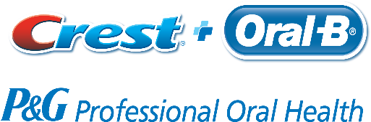
TEACH & LEARN or APPOINTMENT REQUEST FORM
Please scan & email form to sanchez.bs.1@pg.com OR photo & text form to 928-215-5895
OR Call Brenda Sanchez to schedule or for more information 928-215-5895

Virtual Teach & Learn/Appt (Yes / No) or In- Person Teach & Learn/Appt (Yes / No)
For Virtual: Does Office computer have a Web camera? _____________ Does your Office computer have audio? _________
For Virtual: What platform are you familiar with? Webex _______ Zoom_______ Microsoft Teams ______ Other_______?
Office Name: _______________________________ Contact Person: __________________________
Office Phone: ___________________________ Email: __________________________________________
# team members attending: __________________

What time works best for your office?
 | Monday | Tuesday | Wednesday | Thursday | Friday
Before 8am
11am - Noon
Noon – 1pm
1pm – 2pm
After 5pm

What would you like to learn more about?
- NEW! Oral B iO Transformational Gum Health Bundle
- Implant Bundle
- Ortho Bundle
- Gingivitis Bundle
- Kids Bundle
- “Test Drive” in-office patient trial
- Crest Stannous Fluoride Toothpastes – Gum Detoxify, Gum & Sensitivity
- Oral-B Manual Toothbrushes
- Other: ___________________________________________________________________________________
Which brand(s) does your office currently recommend or dispense?
Crest _______ Colgate _______ Sensodyne _______ Sonicare _______ Water Pik _______ Other? ______________

